- Create one VPC, with 1 public subnet and 1 private subnet.
• Log in to AWS Management Console.
• Search for VPC and open the VPC Dashboard.
• Click Your VPCs → Create VPC.
• Select VPC only.
• Enter VPC name and CIDR block (10.0.0.0/16).
• Click Create VPC.
• Go to Subnets → Create subnet.
• Select the newly created VPC.
• Create a public subnet with CIDR (10.0.1.0/24).
• Create a private subnet with CIDR (10.0.2.0/24).
• Enable Auto-assign public IPv4 address for the public subnet.
• Go to Internet Gateways → Create internet gateway.
• Attach the Internet Gateway to your VPC.
• Go to Route Tables → Create route table for the public subnet.
• Add route 0.0.0.0/0 with the Internet Gateway as the target.
• Associate the public subnet with the public route table.
• Create another route table for the private subnet.
• Associate the private subnet with the private route table.

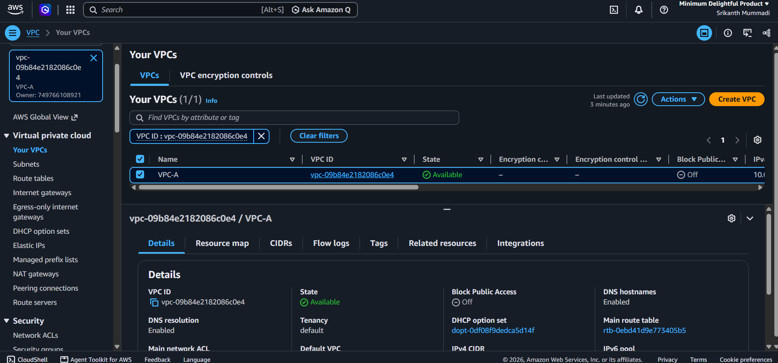
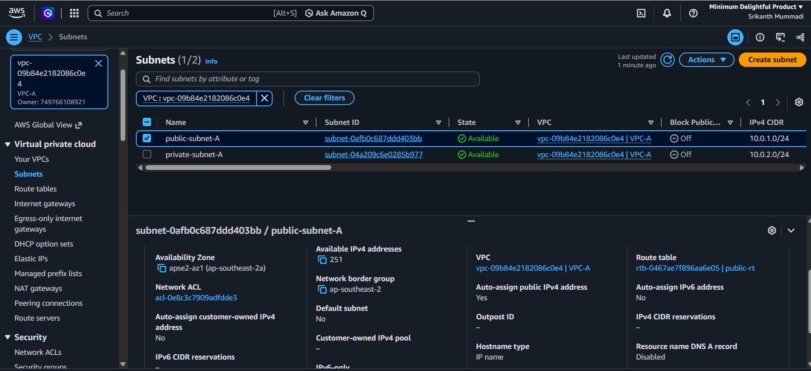
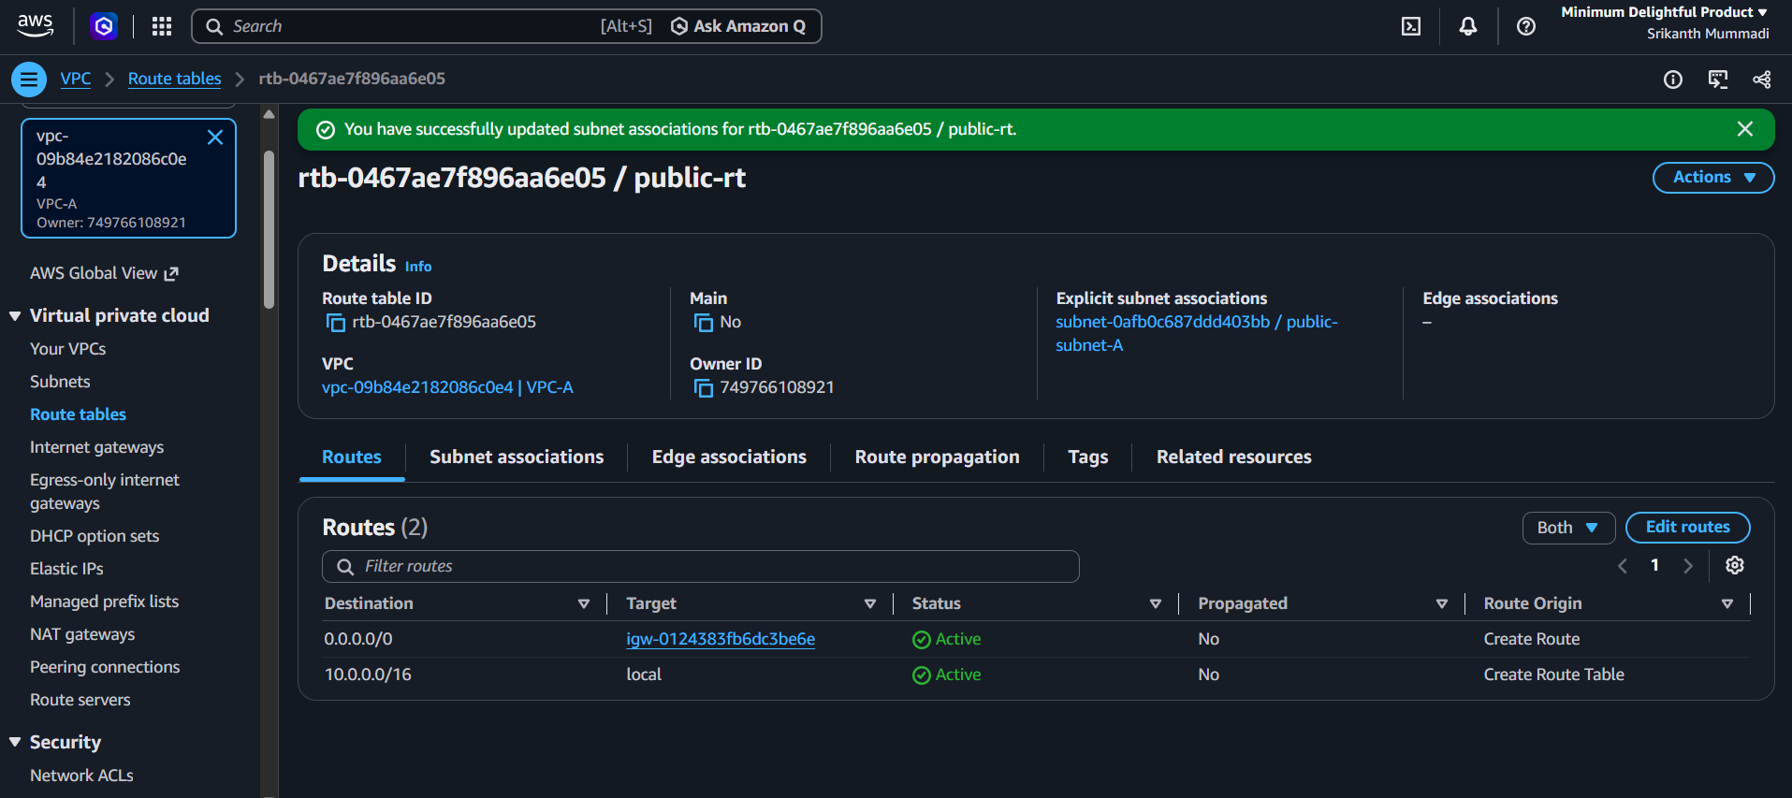

- Enable VPC peering for cross-region.
• Log in to AWS Management Console.
• Create two VPCs in different AWS regions.
• Ensure both VPCs have non-overlapping CIDR blocks.
• Open VPC → Peering Connections in the requester region.
• Click Create peering connection.
• Enter the requester VPC details.
• Select Another Region and choose the accepter region.
• Select the accepter VPC.
• Click Create peering connection.
• Switch to the accepter region.
• Open VPC → Peering Connections.
• Select the pending peering request and click Accept request.
• Update the requester VPC route table with the accepter VPC CIDR and peering connection as target.
• Update the accepter VPC route table with the requester VPC CIDR and peering connection as target.
• Configure Security Groups to allow required traffic.
• Verify that the peering connection status is Active.

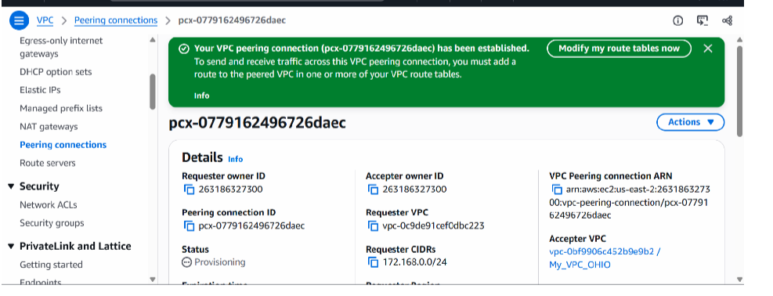

- Enable VPC peering for cross-account (you can collaborate with your friend to do this task).
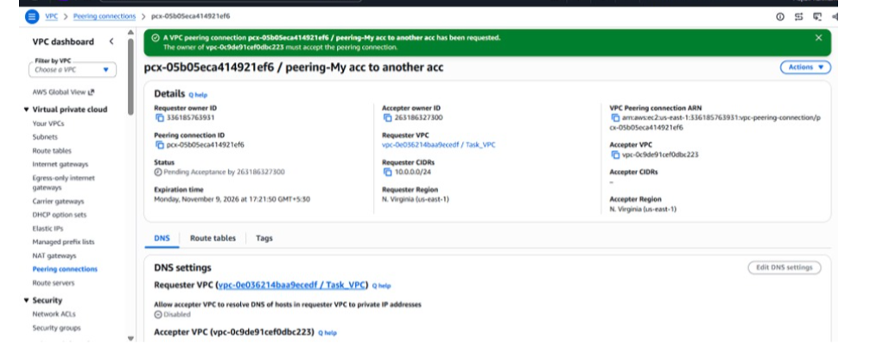

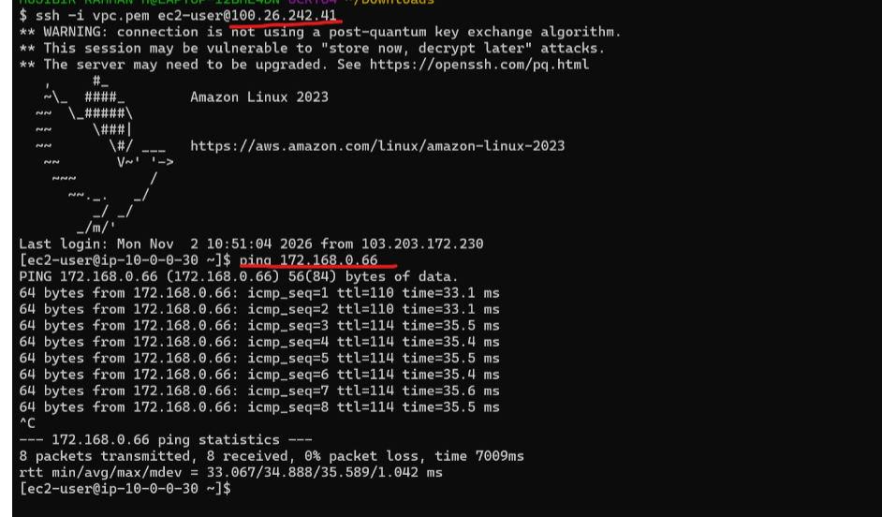

- Set up a VPC Transit Gateway.
• Log in to the AWS Management Console.
• Search for VPC and open the VPC Dashboard.
• From the left navigation panel, select Transit Gateways.
• Click Create transit gateway.
• Enter the Transit Gateway name: my-transit-gateway.
• Add a description: Transit Gateway for VPC communication.
• Set the Amazon side ASN to the default value.
• Keep the default options for other settings.
• Click Create transit gateway.
• Wait until the status changes to Available.

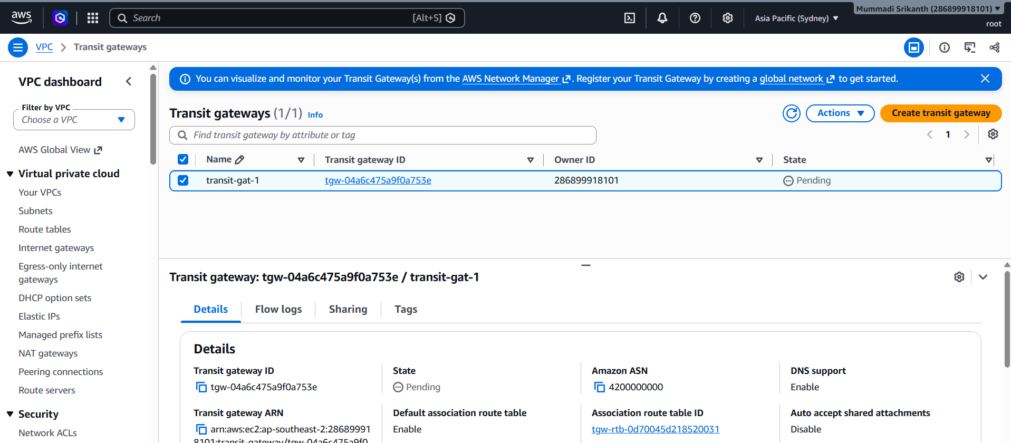

- Set up a VPC Endpoint.
• Log in to your AWS Management Console.
• Search for VPC and open the VPC Dashboard.
• From the left-side navigation panel, select Endpoints.
• Click Create endpoint.
• Enter the endpoint name: my-endpoint
• Under Service category, select AWS services.
• In the Service search box, type S3.
• Select the S3 service with the Gateway type.
• Under VPC, select your existing VPC.



